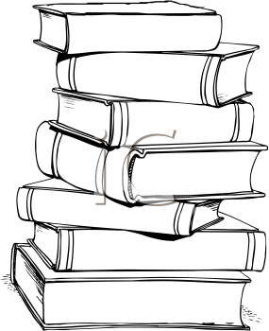
2015 Reading Challenge
Challenge yourself! See if you can read one of each of the following this year:

A classic
A book you already own, but haven’t read yet
A childhood favorite
A book published this year
A book with a one word title
A biography or autobiography
A book that is at least 100 years old
A library book
A book recommended by a friend
A book in a genre you typically don’t read
A book ordered through MeLCat
That book that’s been on your to-read list for forever…
A book set in a place you’d like to travel to
A book that will motivate/inspire you
A work of nonfiction
A book about a current important topic or issue
A book that was made into a movie
A book by a favorite author that you haven’t read yet
A humorous book
That book that EVERYONE but you has read. There has to be a reason, right?
A book with a color in the title
A Shakespeare play
A book published the year you were born
A book about a different culture

